May 2023
RD/RDA: Mid-Atlantic Region
Regional Report

Hello All,

Below is a summary of the Events since last Region.

NEZF meeting – April 23, 2023
Proposals (Motions):

- Zonal Service Symposium Proposal – NESSNA (April 26-28 at the Boston Peabody Marriot in Peabody, MA) to host April 2024 NEZF in person meeting rotation in conjunction with the service symposium. PASSED

- Zonal Identity & Function Proposal - to Update Vision, Mission and Purpose to Reflect Current Services Model of Zone Draft for consideration PASSED

- Website Hosting Proposal: to switch hosting/domain to a2hosting in order to support the NEZF website and future potential. It would also give the NEZF the ability to host NESSSNA’s site, saving hosting cost there. PASSED
(Mid-Atlantic abstained because voting on the proposal took place B4 we were able to bring it back to the Region – will like to add to discussion – having a vote of conscience at NEZF for housekeeping proposals)

- Elections for the Future of the WSC Workgroup (each Zone selects one person to be on the workgroup). Sandy from the ABCD Region was elected (nominated by Mid-Atlantic)
- An NA member (Tom C. from Buffalo) stepped up to be a Chair for a H&I Workgroup that will be under the PR committee umbrella – the workgroup had their 1st meeting with 15 attendees.
- A website was created by the US Collaboration of Zones and is being tested. Please let the members of the Groups know at Area so they can check out the website and give feedback. Link to website below:

https://usa-na.org/public/

- Next meeting of the Collaboration of Zones will be:
  - Midwest Zonal Forum will host July 9, 2023 at 6:00pm Eastern
  - Next meeting of the NEZF will be virtual in July

World Service Conference – April 28, 2023 through May 7, 2023: Summary of WSC included in separate attachment.

Main Points from WSC

- WSC cycle changed to every 3 years (will need to update RD/RDA policy). Scott and I will work on updates and collaborate with Policy as needed.
- Issue Discussion Topics (IDT)
- Motion 21: Create a project plan for the next WSC to update the H&I handbook and remove outdated terms & references (Amendment passed).
- Motion 15: committed to WB: To direct the World Board to create a project plan for the next WSC to initiate the process for the Fellowship to approve adding “gender” to “What is the NA Program?” to read: “Anyone may join us regardless of age, race, gender, sexual identity, creed, religion or lack of religion.”
Intent: To change ‘What is the NA Program’ to be more gender-neutral and inclusive.
- Moving forward WSC funding for RDs will be available upon request.
- Motion 37: To adopt the 2023–2025 Reimbursement Policy. Change from $60 to $70.
- As per Regional policy: (1000.04) Elections for alternate RD will be held every two years, with the elections held in June.
Our Region no longer meets in June but rather July. I will stay on as Regional Delegate till July 2024. This will give me time to help update RD/RDA policy, guide our RDA through NEZF, MARLCNA and create guidelines that will help future RDs in this position. The responsibilities of the RD/RDA have expanded over the years and they are not reflected in our policy.

- I also included a copy of the current and planned revisions for the NEZF Vision and Mission statement.
- I am submitting a motion for a check in the amount of $30.00 fot the NEZF as Mid-Atlantic’s contribution to the zonal website.

Lastly, I also included an attachment for a May newsletter for RCMs to give to their Areas and/or members.

Summary of Decisions:

- Vote on changes to NEZF Vision, Mission statement
- Feedback on US Collaboration of Zones test website:

https://usa-na.org/public/

PROPOSAL/MOTION:

“To Update Vision, Mission and Purpose to Reflect Current Services Model of Zone Draft for consideration”

Below is a copy of the current Vision, Mission and Purpose (1) and Drafted Vision, Mission and Purpose (2). Please bring this Zonal Motion back to your Areas, discuss and be ready to vote at our July face-to-face Regional meeting.

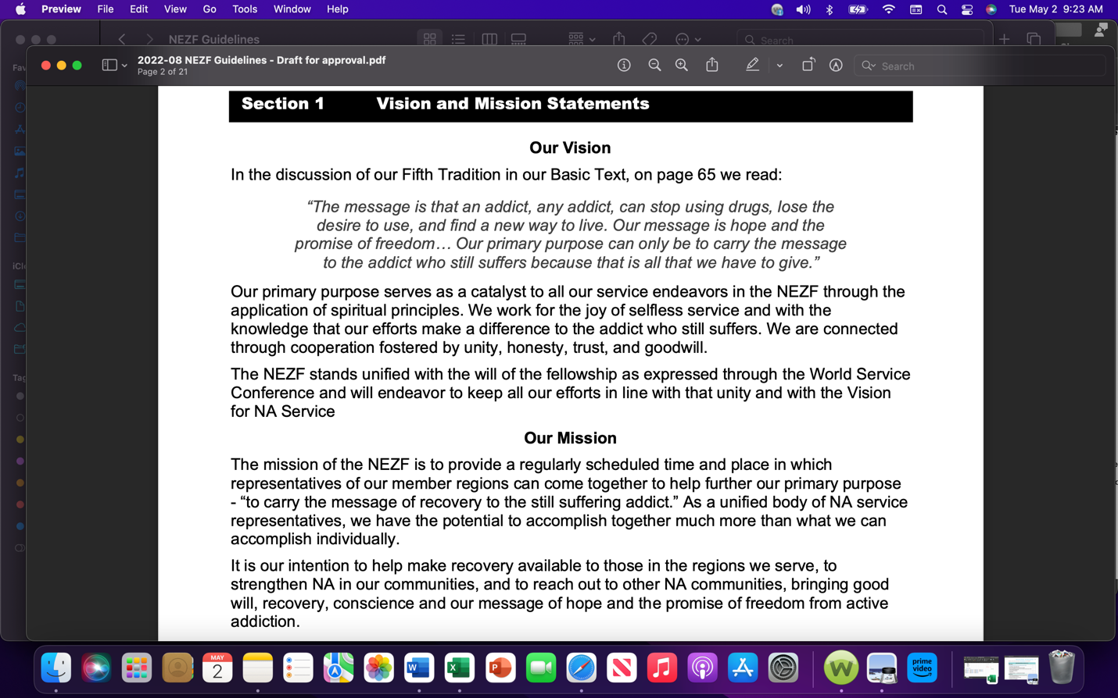

Drafted Vision, Mission and Purpose (2)
