



[This Photo](http://lepamphletaire.blogspot.ca/2011/08/je-suis-contre-narcotique-anonyme.html) by Unknown Author is licensed under [CC BY-SA](https://creativecommons.org/licenses/by-sa/2.0/)



[This Photo](http://lepamphletaire.blogspot.ca/2011/08/je-suis-contre-narcotique-anonyme.html) by Unknown Author is licensed under [CC BY-SA](https://creativecommons.org/licenses/by-sa/2.0/)

LCANA Unity day

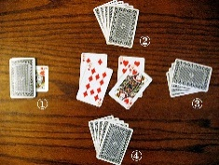Speaker Jam & dance

|  |
| --- |
| **September 7, 2019**  **521 CLUB**  **2400 Butter Rd Lancaster, Pa 17601**  **1:30 pm – 7:30 pm**  **Dinner 5:30 pm – 6:30 pm**  **Dance 8 pm – 12 am $5**  **BELINDA B – 717-779-9578**  **DWYANE t – 717-341-1244**  **FOOD FUN & FELLOWSHIP**  **COME JOIN THE ACTIVIITIES** |
|  |
|  |