GPRCNA XXIX
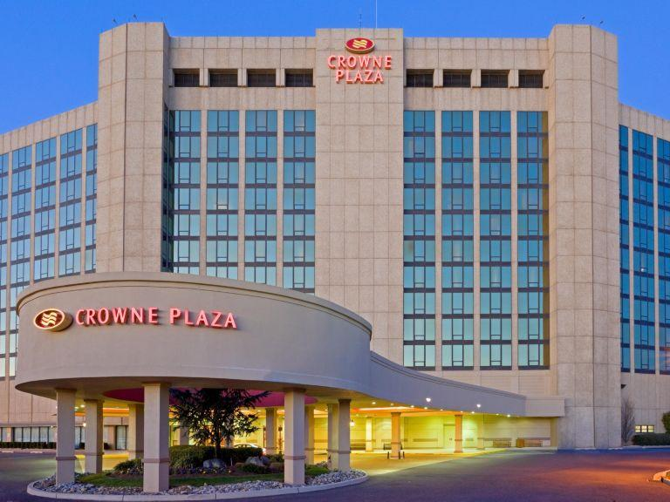
“FREEDOM WITH NO LIMITS”
JUNE 7-9, 2019
CROWNE PLAZA PHILA/CHERRY HILL
2349 WEST MARLTON PIKE
CHERRY HILL, NJ 08002

ROOM RATE: $135.00 +TAX
KING AND DOUBLE OCCUPANCY
Check in after 4:00 p.m.
Check out by 11:00 a.m.

RESERVATIONS: Tele: 888-233-9527 or follow link on naworks.org
BETWEEN 7:00 AM AND 11:00 PM EST
MENTION “GPRCNA” FOR GROUP RATE

RESERVATION DEADLINE: MAY 6, 2019

FIRST 50 RESERVATIONS RECEIVES A GIFT!

HOTEL INFO. CONTACT: CATHY T., CHAIR @ 215-847-0688 or NICOLE S., CO-CHAIR @ 215-584-8738

